VT STORMWATER MANAGEMENT

FACT SHEET

**Disposal of Landscaping Waste**

This fact sheet outlines the proper disposal of landscaping waste. Landscape maintenance activities include vegetation removal, herbicide and insecticide application, fertilizer application, watering, and other gardening and lawn care practices. Proper landscape management can effectively reduce water use and contaminated runoff.

Potential Waste Materials:

* Leaves
* Brush
* Weeds
* Grass Clippings
* Shrubbery Clippings
* Branches
* Tree Trimmings

**Best Management Practices:**

* Direct mowing operations away from open water bodies, streets, or storm drains so grass clippings/debris do not enter the storm sewer system.
* Avoid mowing before predicted rainfall events.
* Avoid mowing grass too short (keep grass at least 3 inches tall for optimal infiltration).
* Leaving clippings on the lawn reduces the lawn’s water loss and lessens the need for fertilizer.
  + Leaving grass clipping on the lawn after mowing ensures that nutrients will be returned to the soil. Grass clippings are 20-30% protein and usually contain about 4% nitrogen, 2% potassium and 0.5% phosphorus as well as all the necessary trace elements plants need.
* Properly time fertilizing, weeding, pest control, and pruning. Do not apply fertilizers to the landscape before a predicted rain event.
* Compost leaves, sticks, or other collected vegetation.
* Do not stockpile or dispose of vegetation near waterways or storm drain systems. *See Photo 1*.
* Contain all landscaping wastes by using bagging equipment, manually picking up the material, and/or creating a temporary stockpile.
* Place temporarily stockpiled material away from watercourses and storm drain inlets. Cover stockpiles to prevent the release of materials to the storm sewer system.

**NOTE:**

**Follow all federal, state, and local laws and regulations governing the use, storage, and disposal of fertilizers and pesticides and training of applicators and pest control advisors.**

**If an overabundance of landscaping waste enters the storm sewer system contact Environmental Health and Safety at (540) 231-3600.**

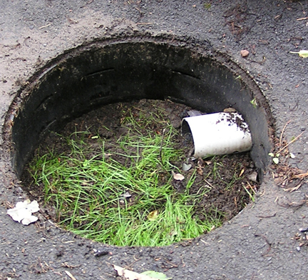 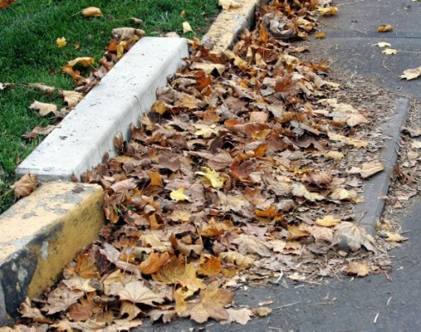

**Photo 1:** Potential Effects from Landscaping Waste in the Storm Sewer System.